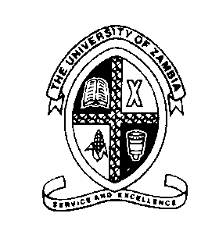

THE UNIVERSITY OF ZAMBIA
SCHOOL OF MEDICINE
DEPARTMENT OF BIOMEDICAL SCIENCES

BMS 3215, MEDICAL GENETICS
ASSESEMENT I
(3rd Year BSc Biomedical Sciences Students)

INSTRUCTIONS
There are FIVE (5) short-notes questions in this paper. Answer ALL questions in this paper. Each question carries 10 marks. Each question must be answered on a separate paper.

- Describe the four types of genetic disorders (examples)
- Numerical and structural chromosomal abnormalities

- Benefits and implications of Human Genome Project (HGP)
- State Mendel`s Laws of inheritance and give examples of each law

END OF TEST

