30th November 2015

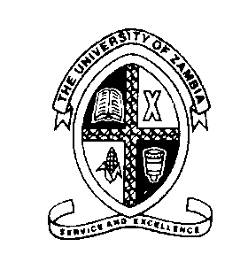

The University of Zambia
School of Medicine
Department of Biomedical Sciences

Medical Genetics, BMS 3215
Assessment I
(3rd Year BSc Biomedical Sciences)

SECTION A SHORT NOTES: There are four (4) short-answer questions in this section. Each question in this section carries equal marks (10 marks each). Answer ALL the questions in this section. Each Question must be answered on a separate paper.

- In cats there is hereditary blindness caused by a recessive gene. A heterozygous hearing cat is crossed with a deaf cat. Using a Punnett square determine the characteristics of the offspring.
- Briefly explain the patterns of inheritance of the ABO blood group system
- Briefly discuss the causes and consequences of point mutations
- Define the following terms and give an appropriate example for each term:
- Aneuploidy
- Pericentric invasion
- Robertsonian translocation
- Submetacentric chromosome
- Genetic mosaicism

SECTION B: There are two (2) Long-essay questions in this section. Answer ALL questions in this paper. Each question carries 20 marks. Each Question must be answered on a separate paper

- In a certain town there were two men named Phiri and Choolwe. Choolwe had a rare disease called EZ syndrome and married Ruth who didn’t have this genetic disorder and these two had four daughters named B1, B2, B3 and B4 (B1 and B3 inherited EZ disease but not B2 and B4). Phiri was phenotypically normal and married Elizabeth who was a carrier of EZ disease. Elizabeth gave birth to fraternal twins (named A1 and A2). A1 had the same disease as the mother but A2 didn’t have. 28 years later, A2 married Mr Choolwe`s daughter (B1). B1 and A2 had four children (three boys and one girl) of which one boy and one girl had EZ disease and the rest didn’t have the named disease.
- By using a pedigree, illustrate the family relationships of Phiri and Choolwe (5 marks)
- What mode of inheritance does the pedigree you have constructed depicts and give reasons for your answer (10 marks)
- Would the pattern of inheritance you mentioned above changes (and give reasons) if Ruth and Choolwe were a proband of a consanguineous marriage? (5 marks)

- Explain in detail how mitosis differs from meiosis

