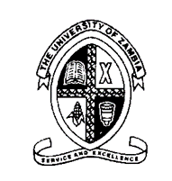
University of Zambia
School of Medicine
Department of Biomedical Sciences

BSc Biomedical Sciences: Third Year
Medical Genetics: BMS 3215

Assessment Test III

Friday, 8th April, 2016 16:30-18:30

Section A: Short Answer Questions. Answer ALL the 3 questions. Each question MUST be answered on a SEPARATE answer sheet (10 marks each)

- Briefly explain the patterns of inheritance of the ABO blood group system
- Briefly discuss the consequences of the Human Genome Project
- Briefly discuss the different types of cloning

Section B: Essay-Type of Questions. There are Two (2) questions in this section. Answer ALL the questions. Each Question must be answered on a separate sheet (20 marks each)

- By giving appropriate examples, discuss the different types of mutations (20 marks)
- Discuss the characteristics features of the following patterns of inheritance:
- Autosomal recessive (10 marks)
- Autosomal dominant (10 marks)

End of Test

