
The University of Zambia
School of Public Health
Department of Health Policy and Management
Applied Economics (HSM 3210)
Problem Set 1
- Indicate the following statements as true(T) or false(F) and give a justification
- The law of diminishing marginal production states that increased application of one input keeping others fixed will yield smaller output.
- In production under variable proportions the ratio of all variable inputs varies.
- Marginal rate of technical substitution of labour for capital increases as capital decreases and labour increases.
- One unit increase in output due to an extra unit of increment in input is known as marginal product.
- Assume a firm produces a product using two factors A and B. Factor B is fixed at any point of time, while factor A is varied as shown below
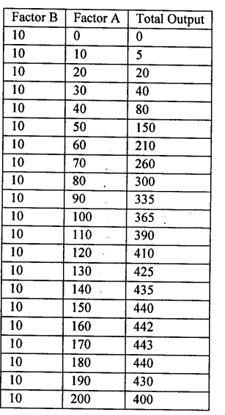
- Compute the Average Physical Product and Marginal Physical Product of factor A at each level of output
- Explain the three stages of production and describe their characteristics

- The table below shows a firms total cost at a given level of output:
Output | 0 | 1 | 2 | 3 | 4 | 5 | 6 | 7 | 8 | 9
TC (ZMW) | 12 | 27 | 40 | 51 | 60 | 70 | 80 | 91 | 104 | 120

- Calculate the marginal and average costs for each level of output
- Show how marginal and average costs are related
- Are these short-run or long-run cost curves? Explain how you can tell.
- Explain with graphical illustrations:
- The expected relationship between the marginal product of labour and the average product of labour
- The relationship between marginal cost and average cost curves in relation to (i) above
- Suppose that firm A has the following short-run production function: Q = $K_{0}√L$, where K denotes capital and L labour. Suppose that the level of capital is fixed at K₀ = 10. The total cost of firm A in the short run is: STC = 10 + wL, where w is the wage paid to each worker. Assume that the wage is K20. Using the production function, show how the short-run total cost depends on the quantity produced Q. Plot the short-run total cost on a graph where you put Q on the horizontal axis.
- The following table shows the data for quantity produced and the total cost of production in the long run for a given firm.
Output | 1 | 2 | 3 | 4 | 5 | 6 | 7 | 8 | 9 | 10
LTC (ZMW) | 102 | 112 | 136 | 180 | 250 | 352 | 492 | 676 | 910 | 1200

- Find the long-run marginal cost and the long-run average cost faced by the firm
- In a graph, plot the LMC and the LAC curves. Where does the LMC curve cut the LAC curve and why?

