
The University of Zambia
School of Public Health
Department of Health Policy and Management
Applied Econometrics
Problem Set 1

1. What is the conditional expectation function or the population regression function?
2. What is the difference between the population and sample regression functions? Is this a
distinction without difference?
3. What is the role of the stochastic error term u_{i} in regression analysis? What is the difference
between the stochastic error term and the residual, û_{i}?
4. Why do we need regression analysis? Why not simply use the mean value of the regress and
as its best value?
5. What do we mean by a linear regression model?
6. Determine whether the following models are linear in the parameters, or the variables, or
both. Which of these models are linear regression models?
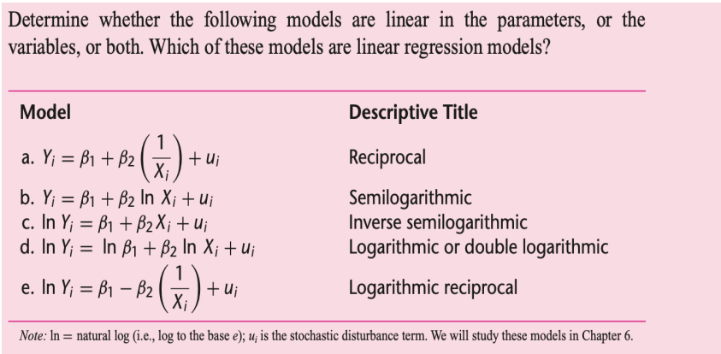
7. Interpret the following graphs in terms of association, correlation and relationship:
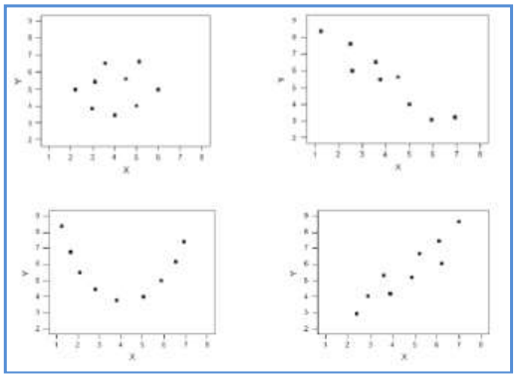

8. Let 𝑋 be a random variable knowing that:
𝐸(𝑥) = 𝜇 𝑎𝑛𝑑 𝑉𝑎𝑟(𝑥) = 𝜎 ²
We have information about four independent observations: 𝑥₁, 𝑥₂, 𝑥₃, 𝑥₄.
Let 𝜇̂₁ $={\frac{1}{4}}$ (𝑥₁ + 𝑥₂ + 𝑥₃ + 𝑥₄) being and estimator for the population mean.
- What are the expected value and variance of 𝜇̂₁ in terms of 𝜇 and 𝜎²?
- Now consider a second estimator for the population mean 𝜇̂2 being defined as:

𝜇̂₁ = $\frac{1}{8}$𝑥₁ + $\frac{1}{8}$𝑥₂ + $\frac{1}{4}$𝑥₃ + $\frac{1}{2}$𝑥₄

- Show that this second estimator is also an unbiased estimator for the population mean. Find its variance.
iii. Based on all your answers, which estimator do you prefer?

